- If you feel that the resources that I have created have helped you save time and/or money, please consider supporting the work that I do by doing your Amazon shopping through TCI By The Lake.

- Simply visit the “Amazon Reviews” section (the last tab on the right of my site’s header) or click here before you do your online shopping and check out my product reviews. You’ll be helping out regardless of what you end up buying.

- I do not sell my resources on Teachers Pay Teachers or any other platform, so feel free to share whatever you’d like with colleagues. Thank you for your support.

- Please email me at marc@tcibythelake.com if you notice an error or a broken link and I will promptly upload a corrected version.

- All the best,
Marc Fencil

Me llamo Alonzo Bosco.

Soy José Gaspar.
Soy Pedro de la Plesa.

Soy Benito de Soto.

Mi nombre es Diabolito.

Me llamo Mansel Alcantra.

Me llamo Elsa la Conquistadora.

Soy Paula la Terrible.

Me llamo Héctor de la Vega.
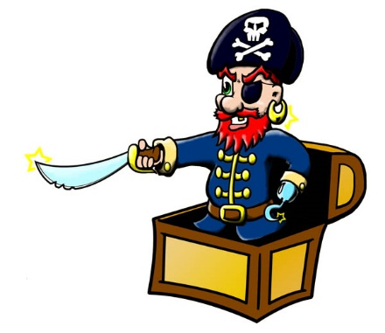

Arrrr, chicos… Vuelvan a la clase de español. ¡El Señor Fencil tiene el tesoro!

