
- TCI by the Lake is a participant in the Amazon Services LLC Associates Program, an affiliate advertising program designed to provide a means for me to earn fees by linking to Amazon.com and affiliated sites.

- If you feel that the resources that I have created have helped you save time and/or money, simply visit the “Support My Work” section (the last tab on the right at tcibythelake.com) or click here before you do your online shopping and check out my product reviews of items you might like to have in your classroom or at home. You will help regardless of what you end up buying.

- I do not sell my resources on Teachers Pay Teachers or any other platform, so feel free to share whatever you would like with colleagues.

- Please email me at marc.fencil@gmail.com
if you notice an error or a broken link and I will fix it promptly. Thank you for your support.

All the best,
Marc Fencil

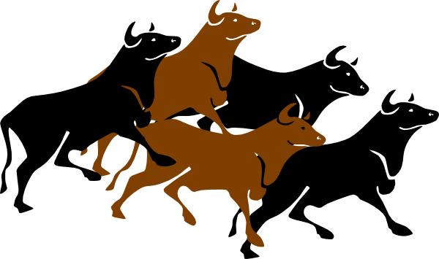

The Running of the Bulls

Nombre _________________________

Hora ______

1. Where does the Running of the Bulls take place (country and city)?

2. What is the name of the festival? In which month does it occur?

3. How many days does the festival last?

4. How do the festival-goers dress?

5. What do their red bandanas represent?

6. What is the name of the famous U.S. author who wrote about bullfighting and the Running of
the Bulls?

7. When do the bulls run? How long do they run?

8. What happens to the bulls who ran later that evening?

9. Do you think this tradition should continue? Why or why not?

10. Would you run with the bulls if you had the opportunity? Why or why not?

